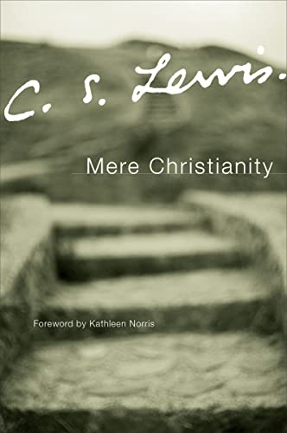
Mere Christianity Study Plan

25 February Orientation week – no reading
4 March Book 1, chapters 1–2
11 March Book 1, chapters 3–4
18 March Book 1, chapter 5
25 March Book 2, chapters 1–2
Break for Holy Week and Easter Holidays (catch-up time)
22 April Book 2, chapters 3–5 *
29 April Book 3, chapters 1–2
6 May Book 3, chapters 3–4
13 May Book 3, chapters 5–6
20 May Break for General Assembly (pray for me)
27 May Book 3, chapters 7–9
3 June Book 3, chapters 10–12
10 June Book 4, chapters 1–3 *
17 June Book 4, chapters 4–6
24 June Book 4, chapters 7–9 *
1 July Book 4, chapters 10–11

* An asterisk is forewarning: the reading this week may be longer/more difficult

Free online PDF: https://preprostost.si/wp-content/uploads/2024/06/Mere-Christianity-C.-S.-Lewis.pdf
Another one: https://www.treasuresinheaven.net/FILES/Mere-Christianity-CS-Lewis.pdf
Free online audiobook: https://www.youtube.com/watch?v=to03M79eeu0

